**Measurement Systems**

**LAB 3: Demonstration of operation of DSO.**

* The **digital storage oscilloscope** is defined as the oscilloscope which **stores and analysis the signal digitally**, i.e. in the form of 1 or 0.

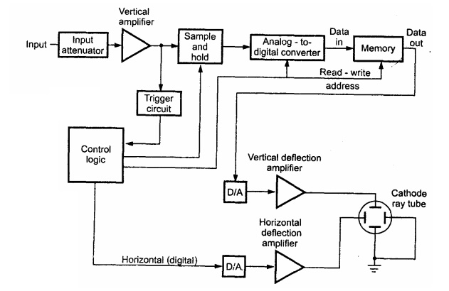

* To digitize the analog signal, analog to digital (A/D) converter is used.
* The output of the vertical amplifier is applied to the A/D converter section.
* The successive approximation type of A/D converter is most oftenly used in

the digital storage oscilloscopes.

* The sampling rate and memory size are selected depending upon the duration & the waveform to be recorded.
* Once the input signal is sampled, the A/D converter digitizes it.
* The signal is then captured in the memory.
* Once it is stored in the memory, many manipulations are possible as memory can be readout without being erased.